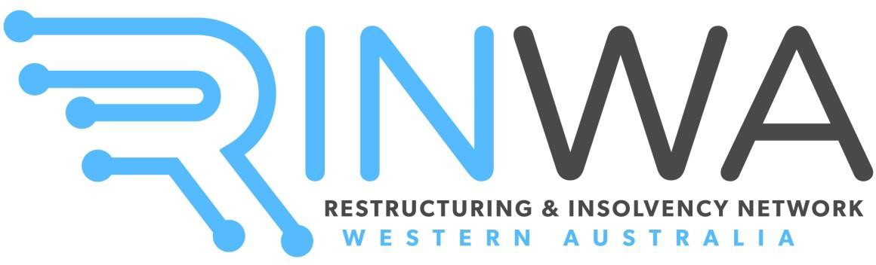

## RINWA – THE INSOLVENCY PROFESSIONALS’ NETWORK INC. (A1009853F)

**Trading as “RINWA Restructuring and Insolvency Network Western Australia”**

# Notice of Annual General Meeting

**Annual General Meeting to be held at HFW Australia, Level 15, Brookfield Place, Tower 2, 123 St Georges Terrace, Perth WA 6000, on Wednesday, 23 October 2024 at 5:30pm (AWST).**

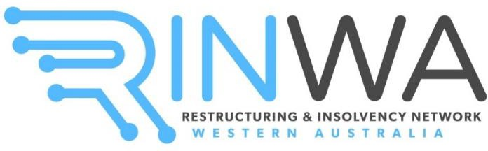

**NOTICE OF ANNUAL GENERAL MEETING**

Notice is hereby given that the Annual General Meeting of “RINWA – The Insolvency Professionals’ Network Inc.” (**RINWA**) will be held at **HFW Australia, Level 15, Brookfield Place, Tower 2, 123 St Georges Terrace, Perth WA 6000, on Wednesday, 23 October 2024 at 5:30pm (AWST).**

Any members who are unable to attend the Annual General Meeting but still wish to vote, may complete the enclosed Proxy Form and email it to the RINWA President, Miss Joanne Nguyen ([jnguyen@kordamentha.com](mailto:jnguyen@kordamentha.com)) by **5:30pm (AWST) on** **Wednesday, 25 September 2024**. If a member wishes to vote via post, please email [committee@rinwa.com.au](mailto:committee@rinwa.com.au).

Voting shall be conducted as per Rule 13.6(c) of the Association’s Rules, via a show of hands. A poll may be demanded by the Chairperson or by three or more Members present, as per Rules 13.6(e)-(f).

**AGENDA**

1. Opening of meeting and welcome.
2. Present and apologies.
3. Approval of the minutes of the previous Annual General Meeting held on 22 November 2023.
4. Disclosure of any conflicts of interest.
5. Consideration of the financial accounts of RINWA, and reports of the Management Committee of RINWA.
6. President speech.
7. Election of Management Committee Members, including:
   1. the Executive Committee, which comprises:
      1. a President;
      2. a Vice-President;
      3. a Secretary;
      4. a Treasurer; and
   2. the General Committee.
8. Any other business.
9. Close of meeting.

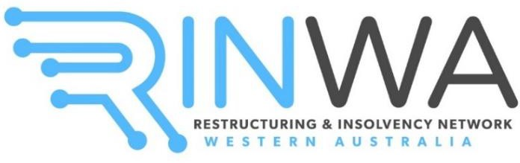

## RINWA – THE INSOLVENCY PROFESSIONALS’ NETWORK INC. (A1009853F)

**Trading as “RINWA Restructuring and Insolvency Network Western Australia”**

# PROXY FORM

I, , a member of RINWA, hereby authorise , a member of RINWA, to vote and speak on my behalf at the Annual General Meeting of RINWA at HFW Australia, Level 15, Brookfield Place, Tower 2, 123 St Georges Terrace, Perth WA 6000, on Wednesday, 23 October 2024 at 5:30pm (AWST).

I hereby give the following specific directions as to how my proxy is to vote on my behalf:

OR

I hereby provide no instructions to my proxy and the proxy may vote as they see fit.

Name:

Signature:

Date:

*Please email this Proxy Form to the RINWA President, Miss Joanne Nguyen (*[*jnguyen@kordamentha.com*](mailto:jnguyen@kordamentha.com)*) by Wednesday, 25 September 2024 at 5:30pm (AWST).*