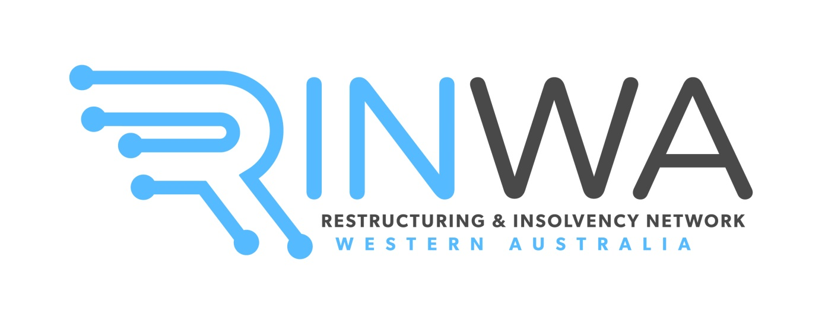

**RINWA – THE INSOLVENCY PROFESSIONALS’**

**NETWORK INC. (A1009853F)**

**Trading as “RINWA Restructuring and Insolvency Network Western Australia”**

**Nomination for Committee of Management FY25/26**

**Annual General Meeting to be held at HFW Australia, Level 15, Brookfield Place, Tower 2, 123 St Georges Terrace, Perth WA 6000, on Wednesday, 23 October 2024 at 5:30pm (AWST).**

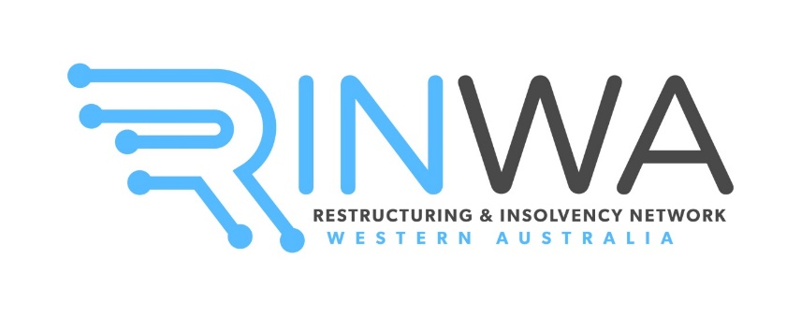

**RINWA – THE INSOLVENCY PROFESSIONALS’ NETWORK INC. (“RINWA”)**

**NOMINATION FOR COMMITTEE OF MANAGEMENT FY 25/26**

The RINWA Committee of Management comprises between 4 and 15 members (being the Executive and the General Committee).

The Executive Committee comprises of:

1. a President;
2. a Vice President;
3. a Secretary; and
4. a Treasurer.

If at the AGM, the number of persons nominated for election to membership of the RINWA Committee does not exceed the number of vacant positions, the Chairperson must declare those persons to be duly elected.

**If you wish to apply for an Executive position, please note that your nomination will need to be seconded by two current RINWA committee members, at the subsequent Committee Meeting held for allocation of committee roles.**

The General Committee comprises 11 committee members, with various roles allocated as required by the Executive. Some roles will be allocated to committee members by the President, and other roles can be separately nominated for by committee members. This will take place at the first Committee Meeting following the AGM.

**If you are a current RINWA member, you can nominate yourself for a position on the General Committee. If you are not a current RINWA member, a current member will be required to nominate you (and you will need to become a member for FY25/26).**

**For any queries in relation to the above, please email** [**committee@rinwa.com.au**](mailto:committee@rinwa.com.au)**.**

If you wish to nominate, please complete the enclosed nomination form and return to the RINWA President, Miss Joanne Nguyen by email at [jnguyen@kordamentha.com](mailto:jnguyen@kordamentha.com) by no later than **Wednesday,** **25 September 2024 at 5:30pm (AWST).**



**RINWA MANAGEMENT COMMITTEE NOMINATION FORM**

Nominees must be aware that a modest time commitment is expected from all RINWA committee members. In nominating for membership of the RINWA committee, nominees confirm that they will:

* not miss not more than 3 committee meetings per financial year (as a guide, approximately 10 meetings are usually held per financial year);
* attend at least 3 RINWA events for the financial year; and
* perform the role assigned to them by the committee and provide updates on that role at committee meetings as required from time to time.

By signing the nomination form, the nominee also verifies that they are eligible to serve as a Committee Member and meet the requirements of the *Associations Incorporation Act 2015* (WA). That is, that they are not an excluded person under the Act (e.g. are bankrupt or their affairs are managed under insolvency laws or have been convicted of particular offences).

The above matters reflect RINWA’s Rules of Association. All successful nominees will be provided with a copy of the Rules of Association upon election.

I, (*name*) ________________________________________________________________ of

(*firm/organisation*) ___________________________________________________________

nominate myself / have been nominated by

__________________________________________ of

(*firm/organisation*) ___________________________________________________________

for election to the Committee of Management of RINWA.

I/we verify that:

* the nominee is not an excluded person under the Act;
* the nominee is a financial member of RINWA for the year 2024 - 2025 / undertake that the nominee will be a financial member of RINWA on or before the date of the AGM which will be held on Wednesday, 23 October 2024; and
* the nominee acknowledges the obligations of committee members set out in this Nomination Form and undertakes to comply with those obligations.

|  |  |  |  |
| --- | --- | --- | --- |
| Name of nominator: |  | Name of nominee: |  |
| Signed by nominator: |  | Signed by nominee: |  |
| Date: |  | Date: |  |